**INSTITUTE OF AERONAUTICAL ENGINEERING DUNDIGAL, HYDERABAD.**



**TWO WEEKS INTERNSHIP**

**ON**

**AUTOMATIC THYROID ULTRASOUND IMAGE CLASSIFICATION USING FEATURE FUSION NETWORK**

**BY**

**C.PRALAVI**

**21955A0415**

**ELECTRONICS AND COMMUNICATION ENGINEERING**

**UNDER THE GUIDENCES**

**OF**

**PHANI KRISHNA SIR**

# **CERTIFICATE**

This is to certify that this project report is the bonafide work of **CHILUKURI PRALAVI** of roll no **21955A0415** who carried the project entitled “**AUTOMATIC THYROID ULTRASOUND IMAGE CLASSIFICATION USING FEATURE FUSION NETWORK**” under our supervision from May 22 of 2023 to June 4 of 2023.

Submitted for Viva voice Examination held on____________________________

Internal Examiner External Examiner

# **DECLARATION**

I, CHILUKURI. PRALAVI (21955A0415), hereby declare that the Project Report entitled “AUTOMATIC THYROID ULTRASOUND IMAGE CLASSIFICATION USING FEATURE FUSION NETWORK” done by me under the guidance of PHANI KRISHNA SIR , is submitted in fulfilment of Two Weeks Internship Program.

DATE:

PLACE:

SIGNATURE OF THECANDIDATE:

# **ACKNOWLEDGEMENT**

We are pleased to acknowledge our sincere thanks to Board of management of IARE for their kind encouragement in doing this project and for completing it successfully. I am grateful to them.

We convey our thanks to Dr . G RAMU and PHANI KRISHNA SIR for providing us the necessary support and details at the right time during the progressive reviews.

We would like to express our sincere and deep sense of gratitude to our Project Guide PHANI KRISHNA SIR for her valuable guidance, suggestions and constant encouragement paved way for the successful completion of my project work.

**ABSTRACT**

Nowadays, diagnosis of thyroid nodules is mainly based on clinical methods, which requires a lot of manpower and medical resources. Therefore, this work proposes an automated thyroid ultrasound nodule diagnosis method that combines convolutional neural networks and image texture features. The main steps include: Firstly, ultrasound thyroid nodule dataset is established by collecting positive and negative samples, standardizing of images and segmentation of nodule area. Secondly, through texture features extraction, feature selection and data dimensionality reduction, texture features model is obtained; Thirdly, by transfer learning, deep neural network is used to obtain feature model of the nodule in images; Then, texture features model and convolutional neural network feature model are combined to form a new nodule feature model called Feature Fusion Network; Finally, Feature Fusion Network is applied to train and improve performance than single network, and a deep neural network diagnosis model that can adapt to the characteristics of thyroid nodules is built. In order to test this method, 1874 groups of clinical ultrasound thyroid nodules are collected. Harmonic average F-score based on Precision and Recall is used as an evaluation indicator. Experimental results show that Feature Fusion Network can distinguish between benign and malignant thyroid nodules with an F-score of 92.52%. Compared with traditional machine learning methods and convolutional neural networks, performance of this work is better.

Keywords: Ultrasound image, diagnosis of thyroid nodules, texture features convolutional neural network, feature fusion .

**TABLE OF CONTENTS**

|  |  |  |
| --- | --- | --- |
| **CHAPTER** | **TITLE** | **PAGE NO** |
|  | **ABSTRACT** |  |
|  | **INTRODUCTION** |  |
|  | * 1. General Introduction |  |
|  | * 1. Project Objectives |  |
|  | **SYSTEMPROPOSAL** |  |
|  | * 1. Existing System |  |
|  | * + 1. Disadvantages |  |
|  | * 1. Proposed System |  |
|  | 2.2.1 Advantages |  |
|  | * 1. Literature Survey |  |
|  | **SYSTEM DIAGRAMS** |  |
|  | * 1. Architecture Diagram |  |
|  | * 1. Flow Diagram |  |
|  | * 1. UML Diagrams |  |
|  | **IMPLEMENTATION** |  |
|  | * 1. Modules |  |
|  | * 1. Modules Description |  |
|  | **SYSTEM REQUIREMENTS** |  |
|  | * 1. Hardware Requirements |  |
|  | * 1. Software Requirements |  |
|  | * 1. Software Description |  |
|  | * 1. Testing of Products |  |
|  | **RESULTS AND DISCUSSIONS** |  |
|  | **CONCLUSIONANDFUTUREENHANCEMENT** |  |
|  | * 1. Conclusion |  |
|  | * 1. Future Enhancement |  |
|  | **REFERENCES** |  |

1. **INTRODUCTION**
   1. **General Introduction**

Ultrasound images to establish a computer-assisted automated thyroid diagnosis system is an important direction of current research. The commonly applied method of assisting medical diagnosis is to use features extraction engineering and classifiers for classification. For example, Zheng et al used LR (Logistic Regression) to screen out indicators that had a greater impact on judging benign and malignant thyroid. This regression models can achieve pathological classification of images. Liu et al. extracted local texture features of thyroid nodules from region of interest, and applied KNN (K-Nearest Neighbour) algorithm to obtain diagnosis results. Choi and Choi took thresholds and 3D connected region labelling methods to assist doctors in detection by classifiers based on genetic planning. These technologies are based on computer theoretical systems and establish accurate computer diagnosis methods. However, it depends on the completeness of feature textures information and selection of a suitable classifier. With the development of deep learning, some researchers are studying convolutional neural networks to diagnose thyroid ultrasound nodules. For example, Moran et al. established S-Detect technology based on the GoogLeNet. They cooperated with clinical sonographers for joint diagnosis to improve diagnostic performance. Xie et al. decomposed nodules into 9 views to learn 3D features.

They built a multi-view knowledge-based collaborative model for each view and input three images into ResNet-50 network for training to represent appearance, voxel, and shape specificity.

In summary, convolutional neural network usually does not require too much pre-processing operations, and has advantages of convenience and simplicity. However, it is very dependent on feature completeness of training data due to lack of sufficient prior theoretical support. In this case, direction and details of feature training are usually unknown. How to further improve diagnosis accuracy is still urgently needed

* 1. **Project Objectives**
* To enhance the performance of the earliest possible prediction.
* To increase the accuracy of the Classification results.
* To enhance the performance of the overall prediction results.

1. **SYSTEM PROPOSAL**
   1. **Existing System**

Convolutional neural networks to fuse features. In order to fully integrate textures information and image information of thyroid ultrasound, this work builds an integrated convolutional neural network that combine texture features and image features to realize automated pathological diagnosis. Specifically, texture features are extracted by feature engineering method, and it is combined with vector from convolutional neural network to achieve the purpose of further improving network performance

* + 1. **Disadvantages**
* No comparison is made between the accuracies of several algorithm
* It is not proper Segmentation
* The overall classification accuracy was found to be the same irrespective of the kernel types.
* Processing building the model requires fast and efficient processors which is cost consuming
  1. **Proposed System**

Construction of annotated dataset: including image acquisition, cropping, enhancement, and region of interest extraction. Secondly, texture information of nodules is obtained by feature engineering based on patient’s pathology test, and features selection is performed using chi-square correlation test of relationship between feature variable and nodules to eliminate influence of irrelevant variables; Finally, transfer learning is applied to establish a ResNet to achieve feature extraction and image texture features fusion, so that the performance of network is further improved

It is based on using CNN Algorithm

* + 1. **Advantages**
* High performance
* CNN improves the accuracy using Liver images.
* Less time duration

1. **3. LITERATURE SURVEY**

# **Title**: **Revalence of Autism Spectrum Disorder Among Children Aged 8 Years Autism and Developmental Disabilities Monitoring Network, 11 Sites, United States,**

**Year**: **2014**

**Author**: N.V. Ramana Murty and Prof. M.S. Prasad Babu

**Methodology**

The Autism and Developmental Disabilities Monitoring (ADDM) Network is an active surveillance system that provides estimates of the prevalence of autism spectrum disorder (ASD) among children aged 8 years whose parents or guardians reside within 11 ADDM sites in the United States (Arizona, Arkansas, Colorado, Georgia, Maryland, Minnesota, Missouri, New Jersey, North Carolina, Tennessee, and Wisconsin). ADDM surveillance is conducted in two phases. The first phase involves review and abstraction of comprehensive evaluations that were completed by professional service providers in the community. Staff completing record review and abstraction receive extensive training and supervision and are evaluated according to strict reliability standards to certify effective initial training, identify ongoing training needs, and ensure adherence to the prescribed methodology. Record review and abstraction occurs in a variety of data sources ranging from general paediatric health clinics to specialized programs serving children with developmental disabilities. In addition, most of the ADDM.

**Advantage**

* In direct outgrowth of this study was a favourable recommendation for CT-based Brain Tumour screening by several prestigious organizations.

**Disadvantage**

* Administrative costs to be high

# **Title**: **ALE meta-analysis workflows via the Brain Map database: progress towards a probabilistic functional brain atlas**

**Year**: 2016

**Author**: Harleen Kaur and SiriKrishan Wasan

**Methodology**

With the ever-increasing number of studies in human functional brain mapping, an abundance of data has been generated that is ready to be synthesized and modelled on a large scale. The Brain Map database archives peak coordinates from published neuroimaging studies, along with the corresponding metadata that summarize the experimental design. Brain Map was designed to facilitate quantitative meta-analysis of neuroimaging results reported in the literature and supports the use of the activation likelihood estimation (ALE) method. In this paper, we present a discussion of the potential analyses that are possible using the Brain Map database and coordinate-based ALE meta-analyses, along with some examples of how these tools can be applied to create a probabilistic atlas and ontological system of describing function–structure correspondences

**Advantage**

* These systems can offer a great variety of channels and workspaces to facilitate information sharing and communication between health care department.

**Disadvantage**

* Most of the current data mining tools are too complex for use by Health care systems.

1. **SYSTEM DIAGRAMS**

**3.1. ARCHITECTURE DIAGRAM**

**Ultrasound Dataset**

Preprocessing

**Segmentation**

**Splitting Dataset into Train and Test**

**Classification**

**Result Generation**

**Prediction**



**Select and View Dataset**

**3.2. FLOW DIAGRAM**



**Data Preparation**

K mean

**Data Splitting**

**Classification**

**Prediction Result**

**Dataset**

**Selection and Loading**

**Segmentation**

**Split Data into Train and Test**

**Convolution Neural Network**

**CNN**

**3.3.UML Diagram**

**USECASE DIAGRAM**

**ANALYST**

**ER DIAGRAM**

**DATA SELECTION & LOAD**

**Feature Selection**

**CLASSIFICATION**

**RESULT**

**GENERATION**

**CLASS DIAGRAM**

|  |
| --- |
| **DATASET** |
| Select dataset () |
| Import dataset () |
| View dataset () |

|  |
| --- |
| **DATA PREPROCESSING** |
| Resize the images |

|  |
| --- |
| **Feature Selection** |
| Splitting the training and testing dataset () |

|  |
| --- |
| **Classification** |
| Student at-risk Prediction () |
| Prediction () |

|  |
| --- |
| **Analysis** |
| Result Generation () |

**SEQUENCE DIAGRAM**

Feature selection

Classification

Splitting

Prediction

Select

Select dataset

 Load dataset

Start

Result Generation

**ACTIVITY DIAGRAM**

INPUT IMAGE DATA

PRE-PROCESSING

FEATURE SELECTION

TESTING DATASET

TRAINING DATASET

PREDICTION RESULT

1. **IMPLEMENTATIONS**
   1. **Modules**

* Thyroid Image
* Segmentation
* Splitting Dataset into Train and Test Data
* Classification
* Prediction
* Result Generation
  1. **Modules Description**

Thyroid IMAGE

* The data selection is the process of selecting the data for Thyroid Image dataset.
* In this project, detect the Brain Tumor
* The dataset which contains the information about the liver grayscale images

**SPLITTING DATASET INTO TRAIN AND TEST DATA**

* Data splitting is the act of partitioning available data into two portions, usually for cross-validate purposes.
* One Portion of the data is used to develop a predictive model and the other to evaluate the model's performance.
* Separating image data into training and testing sets is an important part of evaluating image processing models.
* Typically, when you separate a data set into a training set and testing set, most of the image data is used for training, and a smaller portion of the data is used for testing.

**CLASSIFICATION**

In [Deep learning](https://en.wikipedia.org/wiki/Deep_learning), a **convolutional neural network (CNN/ConvNet**) is a class of [deep neural networks](https://en.wikipedia.org/wiki/Deep_neural_network), most commonly applied to analyse visual imagery. Now when we think of a neural network we think about matrix multiplications but that is not the case with ConvNet. It uses a special technique called Convolution. Now in mathematics **convolution** is a mathematical operation on two functions that produces a third function that expresses how the shape of one is modified by the other.

**PREDICTION**

* It’s a process of predicting the Thyroid Tumor from the dataset.
* This project will effectively predict the data from dataset by enhancing the performance of the overall prediction results.

**RESULT GENERATION**

The Final Result will get generated based on the overall classification and prediction. The performance of this proposed approach is evaluated using some measures like,

* Accuracy
* Precision
* Recall
* F1-score

1. **SYSTEM REQUIREMENTS**
   1. **Hardware Requirement**

* System : Pentium IV 2.4 GHz
* Hard Disk : 200 GB
* Mouse : Logitech.
* Keyboard : 110 keys enhanced
* Ram : 4GB
  1. **Software Requirement**
* O/S : Windows 7.
* Language : Python
* Front End: Anaconda Navigator – Spyder
  1. **Software Description**

**Python**

Python is one of those rare languages which can claim to be both simple and powerful. You will find yourself pleasantly surprised to see how easy it is to concentrate on the solution to the problem rather than the syntax and structure of the language you are programming in. The official introduction to Python is Python is an easy to learn, powerful programming language. It has efficient high-level data structures and a simple but effective approach to object-oriented programming. Python's elegant syntax and dynamic typing, together with its interpreted nature, make it an ideal language for scripting and rapid application development in many areas on most platforms. I will discuss most of these features in more detail in the next section.

**Features of Python**

**Simple**

Python is a simple and minimalistic language. Reading a good Python program feels almost like reading English, although very strict English! This pseudo-code nature of Python is one of its greatest strengths. It allows you to concentrate on the solution to the problem rather than the language itself.

**Easy to Learn**

As you will see, Python is extremely easy to get started with. Python has an extraordinarily simple syntax, as already mentioned.

**Free and Open Source**

Python is an example of a FLOSS (Free/Libré and Open Source Software). In simple terms, you can freely distribute copies of this software, read its source code, make changes to it, and use pieces of it in new free programs.

FLOSS is based on the concept of a community which shares knowledge. This is one of the reasons why Python is so good - it has been created and is constantly improved by a community who just want to see a better Python.

**High-level Language**

When you write programs in Python, you never need to bother about the low-level details such as managing the memory used by your program, etc.

**Portable**

Due to its open-source nature, Python has been ported to (i.e. changed to make it work on) many platforms. All your Python programs can work on any of these platforms without requiring any changes at all if you are careful enough to avoid any system-dependent features.

You can use Python on GNU/Linux, Windows, FreeBSD, Macintosh, Solaris, OS/2, Amiga, AROS, AS/400, BeOS, OS/390, and # -*- coding: utf-8 -*-

z/OS, Palm OS, QNX, VMS, Psion, Acorn RISC OS, VxWorks, PlayStation, Sharp Zaurus, Windows CE and PocketPC!

You can even use a platform like Kivyto create games for your computer and for iPhone, iPad, and Android.

**Interpreted**

This requires a bit of explanation.

A program written in a compiled language like C or C++ is converted from the source language i.e. C or C++ into a language that is spoken by your computer (binary code i.e. 0s and 1s) using a compiler with various flags and options. When you run the program, the linker/loader software copies the program from hard disk to memory and starts running it.

Python, on the other hand, does not need compilation to binary. You just run the program directly from the source code. Internally, Python converts the source code into an intermediate form called byte codes and then translates this into the native language of your computer and then runs it. All this, actually, makes using Python much easier since you don't have to worry about compiling the program, making sure that the proper libraries are linked and loaded, etc. This also makes your Python programs much more portable, since you can just copy your Python program onto another computer and it just works!

**Object Oriented**

Python supports procedure-oriented programming as well as object-oriented programming. In procedure-oriented languages, the program is built around procedures or functions which are nothing but reusable pieces of programs. In object-oriented languages, the program is built around objects which combine data and functionality. Python has a very powerful but simplistic way of doing OOP, especially when compared to big languages like C++ or Java.

Extensible

If you need a critical piece of code to run very fast or want to have some piece of algorithm not to be open, you can code that part of your program in C or C++ and then use it from your Python program.

**Embeddable**

You can embed Python within your C/C++ programs to give scripting capabilities for your program's users.

**Extensive Libraries**

The Python Standard Library is huge indeed. It can help you do various things involving regular expressions, documentation generation, unit testing, threading, databases, web browsers, CGI, FTP, email, XML, XML-RPC, HTML, WAV files, cryptography, GUI (graphical user interfaces), and other system-dependent stuff. Remember, all this is always available wherever Python is installed. This is called the Batteries Included philosophy of Python.

Besides the standard library, there are various other high-quality libraries which you can find at the Python Package Index.

**FEASIBILITY STUDY**

The feasibility study is carried out to test whether the proposed system is worth being implemented. The proposed system will be selected if it is best enough in meeting the performance requirements. The feasibility carried out mainly in three sections namely.

• Economic Feasibility

• Technical Feasibility

• Behavioural Feasibility

**Economic Feasibility**

Economic analysis is the most frequently used method for evaluating effectiveness of the proposed system. More commonly known as cost benefit analysis. This procedure determines the benefits and saving that are expected from the system of the proposed system. The hardware in system department if sufficient for system development.

**Technical Feasibility**

This study centre around the system’s department hardware, software and to what extend it can support the proposed system department is having the required hardware and software there is no question of increasing the cost of implementing the proposed system. The criteria, the proposed system is technically feasible and the proposed system can be developed with the existing facility.

**Behavioural Feasibility**

People are inherently resistant to change and need sufficient amount of training, which would result in lot of expenditure for the organization. The proposed system can generate reports with day-to-day information immediately at the user’s request, instead of getting a report, which doesn’t contain much detail.

* 1. **Testing of Products**

System testing is the stage of implementation, which aimed at ensuring that system works accurately and efficiently before the live operation commence. Testing is the process of executing a program with the intent of finding an error. A good test case is one that has a high probability of finding an error. A successful test is one that answers a yet undiscovered error.

Testing is vital to the success of the system. System testing makes a logical assumption that if all parts of the system are correct, the goal will be successfully achieved. . A series of tests are performed before the system is ready for the user acceptance testing. Any engineered product can be tested in one of the following ways. Knowing the specified function that a product has been designed to from, test can be conducted to demonstrate each function is fully operational. Knowing the internal working of a product, tests can be conducted to ensure that “al gears mesh”, that is the internal operation of the product performs according to the specification and all internal components have been adequately exercised.

**UNIT TESTING:**

Unit testing is the testing of each module and the integration of the overall system is done. Unit testing becomes verification efforts on the smallest unit of software design in the module. This is also known as ‘module testing’.

The modules of the system are tested separately. This testing is carried out during the programming itself. In this testing step, each model is found to be working satisfactorily as regard to the expected output from the module. There are some validation checks for the fields. For example, the validation check is done for verifying the data given by the user where both format and validity of the data entered is included. It is very easy to find error and debug the system.

**INTEGRATION TESTING:**

Data can be lost across an interface, one module can have an adverse effect on the other sub function, when combined, may not produce the desired major function. Integrated testing is systematic testing that can be done with sample data. The need for the integrated test is to find the overall system performance. There are two types of integration testing. They are:

i) Top-down integration testing. ii) Bottom-up integration testing.

**TESTING TECHNIQUES/STRATEGIES:**

**WHITE BOX TESTING:**

White Box testing is a test case design method that uses the control structure of the procedural design to drive cases. Using the white box testing methods, we

Derived test cases that guarantee that all independent paths within a module have been exercised at least once.

**BLACK BOX TESTING:**

* Black box testing is done to find incorrect or missing function
* Interface error
* Errors in external database access
* Performance errors.
* Initialization and termination errors

In ‘functional testing’, is performed to validate an application conforms to its specifications of correctly performs all its required functions. So this testing is also called ‘black box testing’. It tests the external behaviour of the system. Here the engineered product can be tested knowing the specified function that a product has been designed to perform, tests can be conducted to demonstrate that each function is fully operational.

**SOFTWARE TESTING STRATEGIES**

**VALIDATION TESTING:**

After the culmination of black box testing, software is completed assembly as a package, interfacing errors have been uncovered and corrected and final series of software validation tests begin validation testing can be defined as many,

But a single definition is that validation succeeds when the software functions in a manner that can be reasonably expected by the customer.

**USER ACCEPTANCE TESTING:**

User acceptance of the system is the key factor for the success of the system. The system under consideration is tested for user acceptance by constantly keeping in touch with prospective system at the time of developing changes whenever required.

**OUTPUT TESTING**:

After performing the validation testing, the next step is output asking the user about the format required testing of the proposed system, since no system could be useful if it does not produce the required output in the specific format. The output displayed or generated by the system under consideration. Here the output format is considered in two ways. One is screen and the other is printed format. The output format on the screen is found to be correct as the format was designed in the system phase according to the user needs. For the hard copy also output comes out as the specified requirements by the user. Hence the output testing does not result in any connection in the system.

# **RESULTS AND CONCLUSIONS**

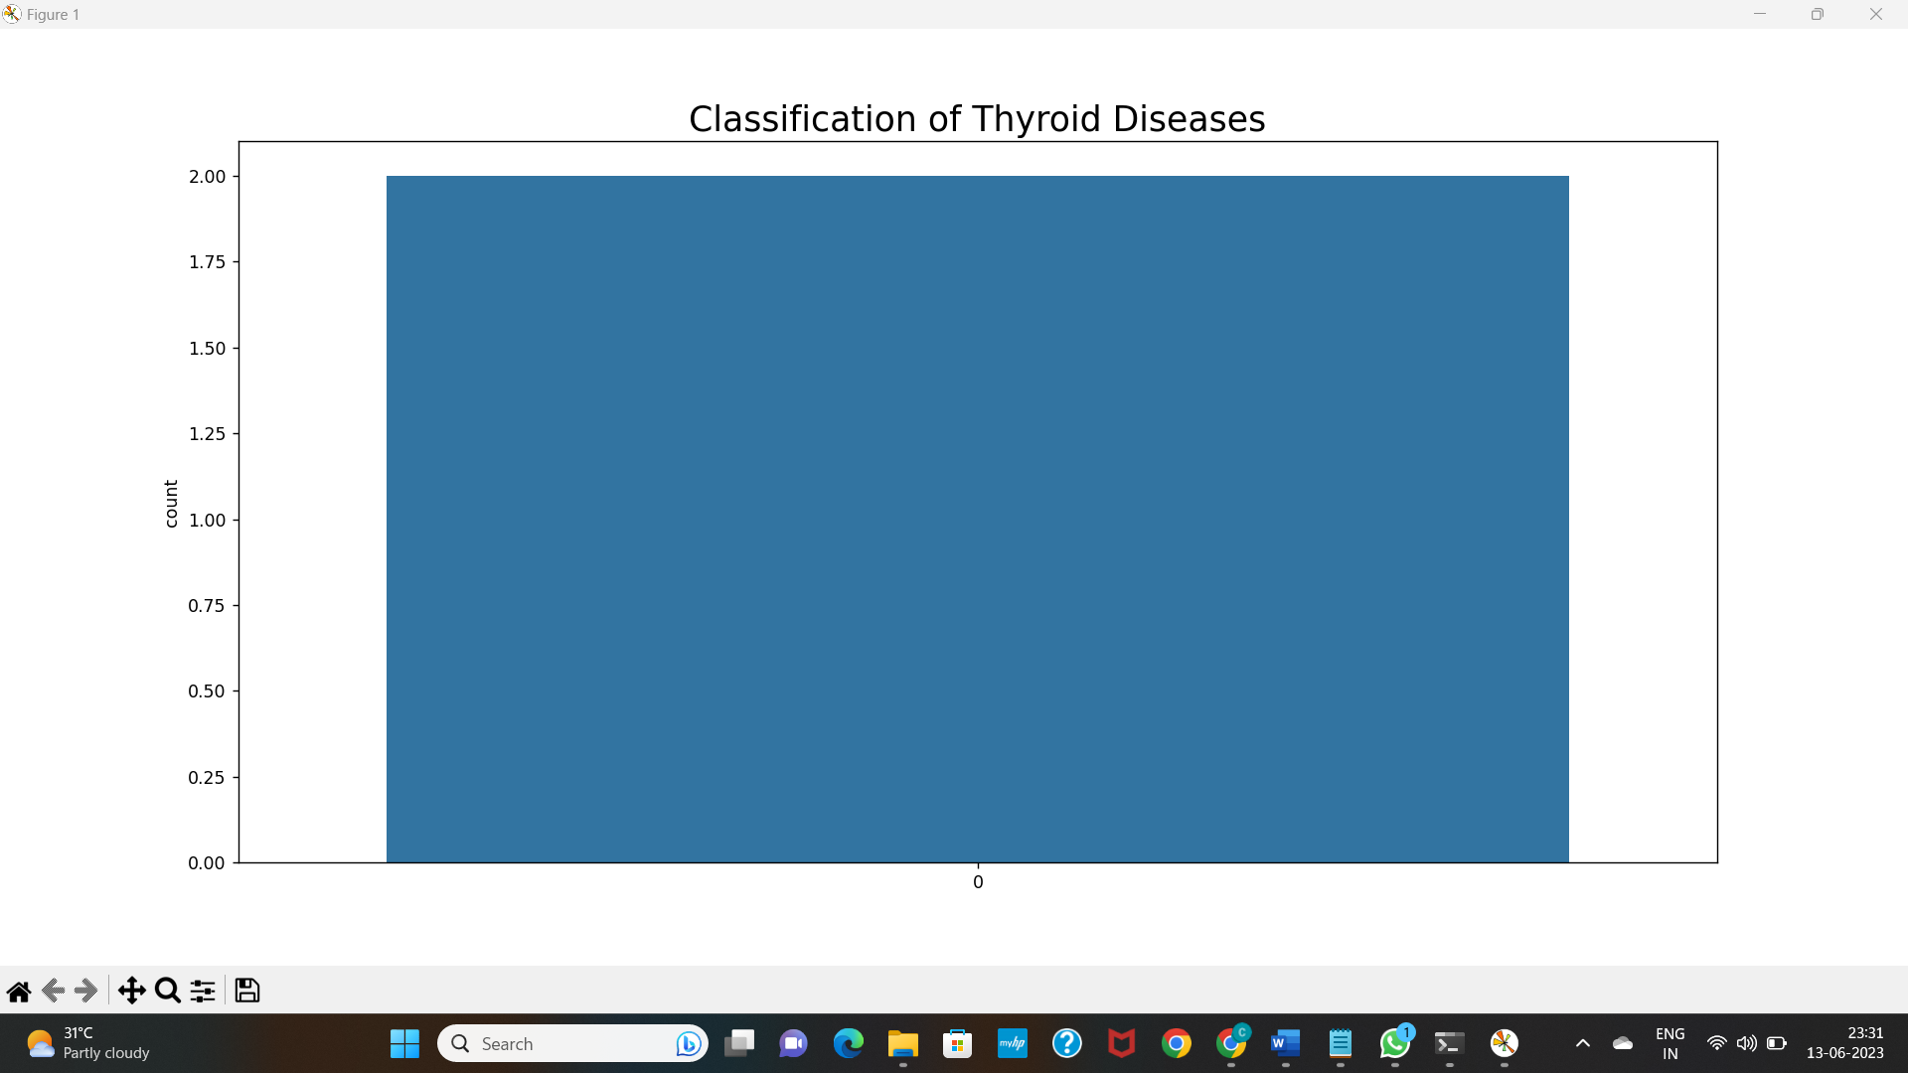

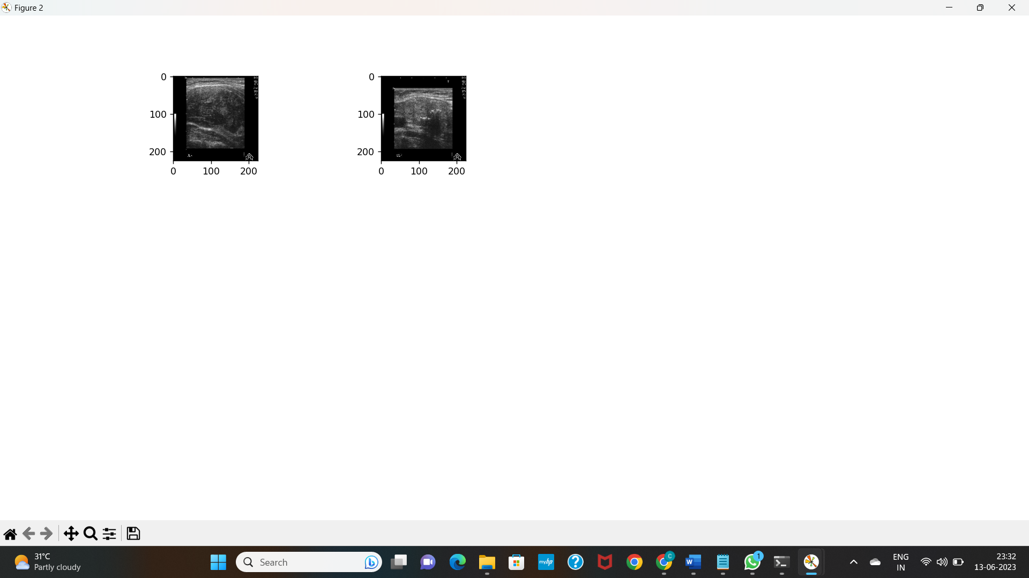

1. **CONCLUSION AND FUTURE ENHANCEMENT**
   1. **Conclusion**

This work combines the advantages of feature engineering and deep neural networks, and proposes a novel way of fusing features. Although this work mainly validates the diagnostic performance of ultrasound imaging of thyroid nodules, this work can also be applied to various domains under the transfer learning and fusion feature structure, such as breast nodules, lung nodules and other tumour diagnosis. It is worth mentioning that the method of fusing features is mainly to introduce more features and information for deep neural network, so that the network can converge more accurately and quickly. This is also a future direction for new fusion information. This work has certain inspirations for computer aided diagnosis, application of deep convolutional networks, and image analysis.

**Future Enhancement**

In the future, different dataset will be investigated to check the system robustness and more CNN models will be tested to improve the performance and identification of smallest tumours

1. **REFERENCE**

1. APA. American Psychiatric Association; DSM-V development: autism spectrum disorder (2013). Available online at: http://www.dsm5.org/ Documents/Autism%20Spectrum%20Disorder%20Fact%20Sheet.pdf

2. Baio J, Wiggins L, Christensen DL, Maenner MJ, Daniels J, Warren Z, et al. Prevalence of autism spectrum disorder among children aged 8 years — autism and developmental disabilities monitoring network, 11 sites, United States, 2014. MMWR SurveillSumm. (2018) 67:1–2

3. Doi: 10.15585/mmwr. ss6706a1 3. Amaral DG, Schumann CM, Nordahl CW. Neuroanatomy of autism. Trends Neurosci. (2008) 31:137–45. Doi: 10.1016/j.tins.2007.12.005

4. Bos DJ, Merchan-Naranjo J, Martinez K, Pina-Camacho L, Balsa I, Boada L, et al. Reduced gyrification is related to reduced interhemispheric connectivity in autism spectrum disorders. J Am Acad Child Adolesc Psychiatry (2015) 54:668–7

6. Doi: 10.1016/j.jaac.2015.05.011 5. Ecker C, Ginestet C, Feng Y, Johnston P, Lombardo MV, Lai MC, et al. Brain surface anatomy in adults with autism: the relationship between surface area, cortical thickness, and autistic symptoms. JAMA Psychiatry (2013) 70:59–70. Doi: 10.1001/jamapsychiatry.2013.265 6. Ecker C, Murphy D. Neuroimaging in autism–from basic science to translational research. Nat Rev Neurol. (2014) 10:82–91. Doi: 10.1038/nrneurol.2013.276

7. Laird AR, Eickhoff SB, Kurth F, Fox PM, Uecker AM, Turner JA, et al. ALE meta-analysis workflows via the brainmap database: progress towards a probabilistic functional brain atlas. Front Neuroinform. (2009) 3:23. Doi: 10.3389/neuro.11.023.2009

8. Libero LE, DeRamus TP, Lahti AC, Deshpande G, Kana RK. Multimodal neuroimaging-based classification of autism spectrum disorder using anatomical, neurochemical, and white matter correlates. Cortex (2015) 66:46–59. Doi: 10.1016/j.cortex.2015.02.008

9. Patriquin MA, DeRamus T, Libero LE, Laird A, Kana RK. Neuroanatomical and neurofunctional markers of social cognition in autism spectrum disorder. Hum Brain Mapp. (2016) 37:3957–78. Doi: 10.1002/hbm.23288

10. Schaer M, Ottet MC, Scariati E, Dukes D, Franchini M, Eliez S, et al. Decreased frontal gyrification correlates with altered connectivity in children with autism. Front Hum Neurosci. (2013) 7:750. Doi: 10.3389/fnhum.2013.00750

* Dou Q, Yu L, Chen H, Jin Y, Yang X, Qin J, et al. 3D deeply supervised network for automated segmentation of volumetric medical images. Med ImageAnal 2017;41:40–54.
* Barstugan. R. Ceylan M, Sivri M, et al. Automatic liver segmentation in abdomen CT images using SLIC and AdaBoost algorithms. In: Proceedings of the 2018 8th international conference on bioscience, biochemistry and bioinformatics. ACM; 2018, p. 129-13.
* Ali AH, Hadi EM. Diagnosis of liver tumour from CT images using first order statistical. Int J Eng Trends Technol (IJETT) 2015;(20).
* Chang CC, Chen HH, Chang YC, et al. Computer-aided diagnosis of liver tumors on computed tomography images.Comput Methods Programs Biomed 2017;(145):45–51.
* Hu P, Wu F, Peng J, et al. Automatic 3D liver segmentation based on deep learning and globally optimized surface evolution. Phys Med Biol 2016;61(24):8676.
* Bi L, Kim J, Kumar JA, et al. Automatic liver lesion detection using cascaded deep residual networks. 2017, arXiv preprint arXiv:1704.0270.
* He K, Zhang X, Ren S, Sun J. Identity mappings in deep residual networks. In: European conference on computer vision. Cham: Springer; 2016, p. 630–45, (9908).
* Han X. Automatic liver lesion segmentation using a deep convolutional neural network method. 2017, arXiv:1702.05747.
* Korabelnikov AN, Kolsanov AV, Chaplygin SS, Zelter2 PM, Bychenkov3 KV, Nikonorov AV. Liver tumour segmentation CT data based on alexnet-like convolutional neural nets. InfTechnolNanotechnol (ITNT-2016) 2016;348–56.
* Bellver M, Maninis K-K, Giró-I-Nieto X, Torres J, Van Gool L. Detection-aided liver lesion segmentation using deep learning. 2017, arXiv:1702.05747.
* Vorontsov E, Tang A, Pal C, et al. Liver lesion segmentation informed by joint liver segmentation. In: Proceeding of the 15th IEEE international symposium on biomedical imaging. IEEE; 2018, p. 98–136.